SS. Cyril and Methodius
Altar Server
Manual
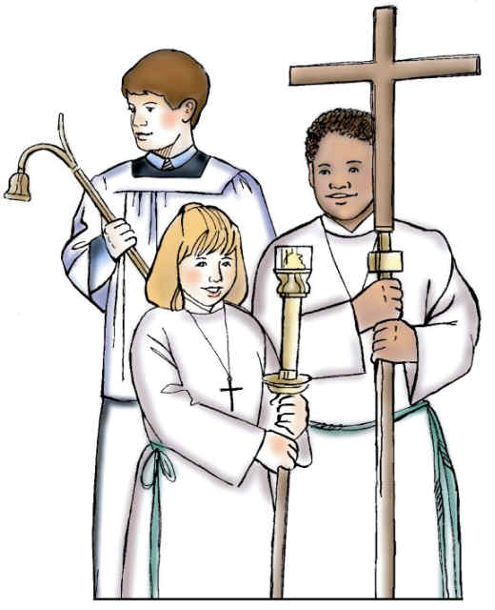

2024

Order of Mass
Introductory Rites
- Entrance procession – Cross Bearer, and two Candles OR one Priest Server Page 3,4
- Greeting
- Penitential Act
- Glory to God
- Opening prayers

Liturgy of the Word
- First Reading
- Responsorial Psalm
- Second Reading
- Gospel Acclamation (Alleluia) – 2 candles Page 4,5
- Gospel
- Homily
- Profession of Faith
- Universal Prayer

Liturgy of the Eucharist
- Preparation of the Altar – book and chalice on altar Page 5,6
- Presentation of the Gifts
- Prayer over the Offerings
- Eucharistic Prayer
  - Preface
  - Holy, Holy, Holy – proceed to kneel at altar rail Page 8
  - First half of prayer, including Consecration – Gong
  - Mystery of Faith
  - Second half of prayer, ending with Doxology
- The Lord's Prayer
- Sign of Peace
- Lamb of God
- Distribution of Communion – re-enter sanctuary, sit, and clear altar Page 8,9
- Prayer after Communion

Concluding Rites
- Optional announcements
- Closing Prayer
- Recessional – Cross Bearer and two Candles OR one Priest Server Page 9,10

Altar Server Guidelines
Introduction
    - Please arrive neatly dressed (refer to Dress Code Sheet) and at least 15 minutes before Mass begins. Proceed to the left side sacristy and put on server’s alb.
    - Check the altar and move the book and chalice to the credence table if they are on the altar. Also check the table at the break (middle of the church) to ensure that the ciborium and wine cruet are there for the presentation of the gifts.
    - At about 5 minutes before Mass, go to the back of the Church to line up for the procession.
    - Please be quiet and attentive on the altar during Mass.
    - Do not be afraid to ask the experienced servers for help or if you have a question.
No cell phones on the Altar please!!!!
Server Positions
- Most of our teams will consist of only 2-3 servers. Certain duties are interchangeable depending on the number of servers present for the mass. See sections of the mass in the duties and responsibilities pages.
- Cross Bearer – the server who carries the cross at the entrance for the procession in and the recession out. Carries the cross to the break for the procession of the gifts. Clears the altar after communion and rings the gong during the Eucharistic prayer. Note: clearing the altar and ringing the gong can be a shared responsibility with the main servers.
- Main Servers/Priest Servers - servers who carry the candles at the entrance for the procession in and the recession out, lead the Gospel procession with the candles, and prepare the altar for the consecration.

WITH ONLY 2 SERVERS - Candles are NOT used at the entrance procession, and the recessional. The server that is not carrying the cross will process in behind the cross (and any other people in the procession) and slightly in front of priest. With only 2 servers, both servers will be the candle bearers for the gospel procession.

Order of Entrance Procession
- Cross
- Candle Bearers (side by side)
- Presider
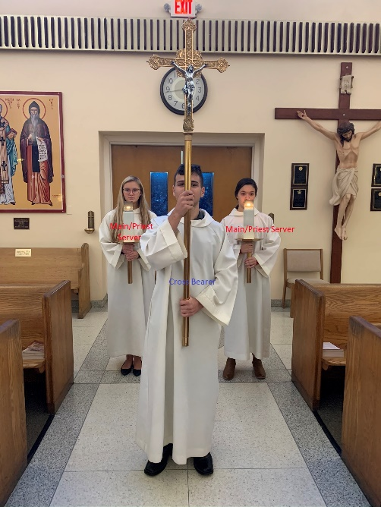
Duties and responsibilities
A. Entrance Procession
    - Line up in back of church. (Use the diamond on the floor.)
    - The Cross Bearer leads the procession when the cantor begins the entrance song.
    - The Main Servers should line up with a candle each behind the Cross Bearer - to his/her left or right. Main Servers should follow the Cross Bearer, but do not walk too close to him/her (about a pew apart). Be mindful of your distance from the other Main Server (a little more than elbow to elbow apart) but always walk together.
    - When you reach the foot of the sanctuary, pause in place for a moment (if you are carrying something, you do not bow), then proceed to replace the cross/candles in its holder. Make sure Jesus on the cross is facing toward you. You may then go to your seat and remain standing. Note: the pause is done to show reverence before entering the altar.
      - If only 2 Servers in total, the server not carrying the cross should not take a candle. For the procession, you should walk behind the cross and slightly ahead of the priest. Pause as you enter the altar and bow your head slightly, then proceed to your seat and remain standing.

  - Gospel Acclamation
      - When the Alleluia is sung, two servers get candles and proceed to stand by the entrance to the sanctuary (in front of the railing) facing the altar.
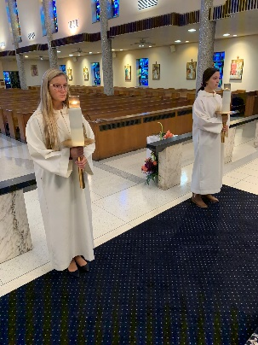
      - The presider will take the Book of the Gospel from the altar table and walk to the front of the altar.
      - When the priest (or deacon) raises the Book and turns to the left, you also turn to your left, walking in a single file line to the lectern/ambo and stand on either side of the ambo facing in (do not step up onto the platform).
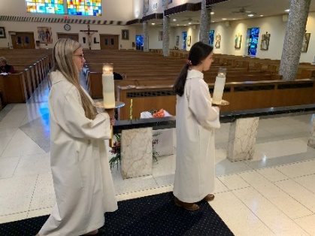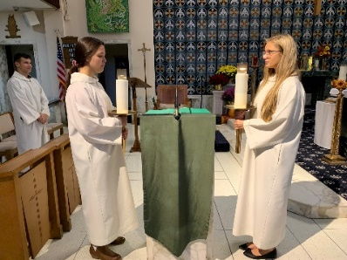
      - Do NOT make the sign of the cross on head, lips and heart while holding candles.
      - After Gospel is read and priest/deacon kisses the Book, place candles back to their holders. The server closes to the middle of the altar should cross in front of the ambo. Do not walk up on the platform. Proceed to your seat and sit down.
  - Liturgy of the Eucharist
- Preparation of the Altar - After the prayer of the faithful, as the cantor announces the offertory hymn, the music begins, and the ushers begin to take the collection.
    - Server 1: One server will take the cross and walk down the aisle to the break (middle of church) where the gifts are. Turn and face the altar. Wait for the family/ushers to line up behind you. Once the presider is standing in front of the altar, process back up toward the altar, entering to your left, and place the cross back in the holder.
    - Server 2/3: One or two servers need to bring the chalice and sacramentary (red book) from the credence table to the altar. The sacramentary goes on the left and the chalice goes on the right. Be sure to grab the clear stand under the sacramentary when you pick it up.
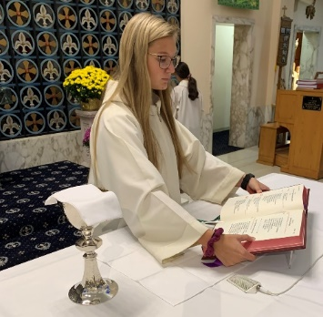

- Receiving Gifts: When the priest walks to the entrance of the sanctuary to receive the gifts, servers 2/3 stand to the right of the priest ready to take the gifts to the altar.
    - Server 2: When the priest hands you the ciborium, take it to the altar and place it on the right side by the chalice. Remove the cover and bring the cover to the credence table. Remain at the credence table. Remove the top of the water cruet and place it on the credence table. Hold the water cruet while waiting for the other server to return to the credence table.

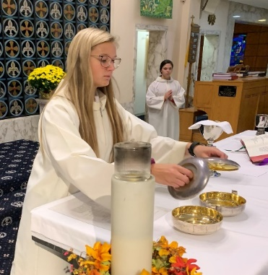

    - Server 3: When the priest hands you the wine, take it to the credence table. Do not put the wine down. If there is a cap on the wine remove it and place the cap on the credence table.
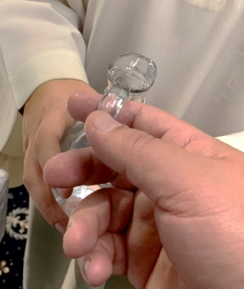
    - Server 2/3: Both servers (holding water and wine) approach the altar. Turn the cruets so the priest can grab them by the handle (as seen in picture). The priest will take the wine and water to fill the chalice. Once the priest returns the cruets to the servers, walk back to the credence table.
- Washing of the Priest’s Hands:
    - Server 2: Stand to the right of server 3 holding the water cruet at the credence table.
    - Server 3: The server holding the wine will place the cruet on the credence table. Next, pick up the towel and drape it over their left arm, then pick up the bowl holding it with two hands. This server should be standing to the left of server 2 who is holding the water cruet.
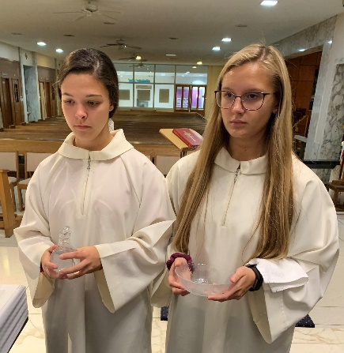
    - Server 2/3: Walk together to the altar to wash the priest’s hands. When the priest holds his hands over the bowl, server 2 will pour water over his hands as he washes his hands/fingers. The priest will use the towel draped on server 3’s arm to dry his hands and then hand it back to the server. After the priest is done washing his hands, he will bow and both servers will bow, then both servers will return the bowl, towel, and water cruet to the credence table and go back to their seats.
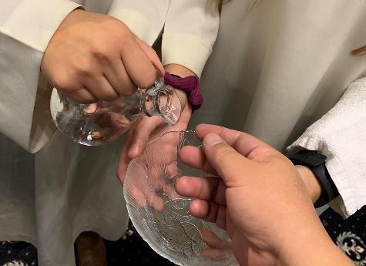
- When the “Holy, Holy, Holy” begins, turn left and process off the altar to the outside of the communion rail. Position yourself in front of a kneeler pad.
- The server in front of the gong will need to hit the gong during the consecration. As the presider raises the host, you will hit the gong on the lower or middle dome, count to 4 and hit it a 2nd time, count to 4 and hit a 3rd time. After the 3rd hit, place your open hand on dome to stop the vibration. Do the same when the presider raises the chalice. It is important to keep the tone the same for each hit and do not tap it lightly. (Note: Not all priests raise the host or chalice high.)
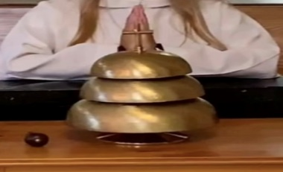
- During the distribution of communion, remain outside the communion rail to receive communion. After receiving communion, kneel and say your prayer. When all are done praying, proceed back to the sanctuary in a straight line to your seats.
- After distribution of communion is complete, the presider will return to the altar. As the priest begins to purify the vessel, bring the water cruet and stand by the altar table. When the presider asks for it, pour some water into the chalice. (Note: the priest may take the cruet and pour it himself. Wait for the priest to hand the cruet back to you.) Return the cruet to the credence table.
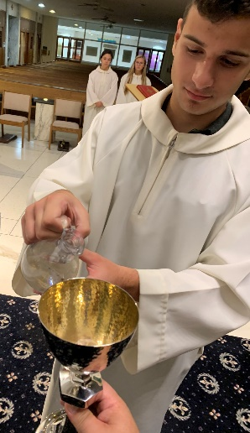
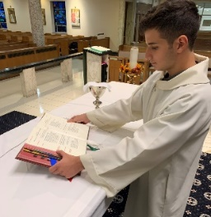
- When the priest places the chalice off to the side or on the small table next to the altar, clear the chalice by taking it back to the credence table, holding it with two hands. At this point, one of the other servers should remove the sacramentary from the altar, and place it back on the credence table.
This is where it is important to watch the priest and take your direction from him. Please walk slowly, watch your step, and use care in passing each other on the altar.

  - Recessional (at the end of Mass)
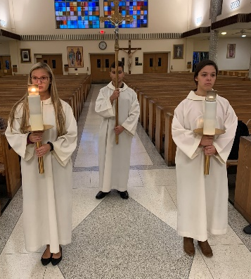
- When the cantor announces the concluding song, the Cross Bearer should take the cross, and the main servers should take the candles and proceed off the altar to the diamond on the center aisle.
- Cross Bearer should stop at the tip of the diamond farthest from the altar and turn around to face the altar.

      - Candle holders should stop on each side of the diamond (left & right) and turn around to face the altar.
      - When the priest bows his head, all should turn around and proceed to the back of the church.
- Remember that the candle bearers should always walk side by side at the same pace.
- Upon reaching the back of the church, turn to your right and proceed to place the cross and candles back in the holders. Please make sure that Jesus on the cross is facing out toward you, not the wall.
- If only 2 servers, the 2nd server does not take a candle. You will follow the cross down to the diamond on the center isle and stand on the point closest to the altar. When the priest bows his head, you bow, then turn and proceed to the back of the church.

ALL SERVERS should remove their albs and hang them neatly when returning them to the closet. Please make sure you zip them up so they don’t slide off the hanger.

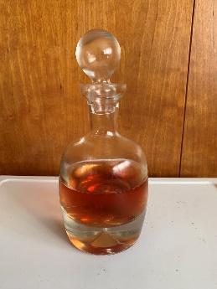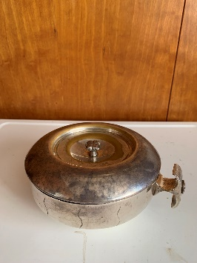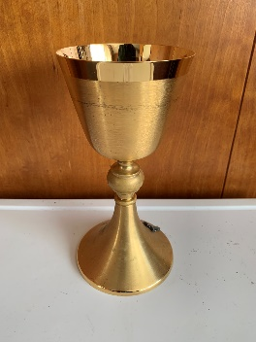
Water Cruet Wine Cruet Ciborium Chalice
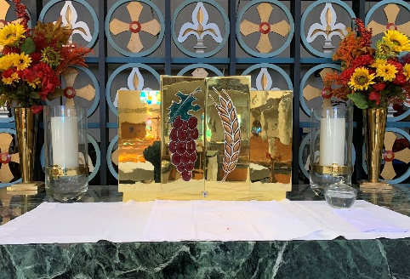
Sacramentary Credence Table Tabernacle

Definitions
albs - the long white vestments used at Mass
altar – the table on which the Sacrifice of the Mass is offered
altar candles – the candles on either side of the altar
altar server – one who serves at God’s table
ambo – the podium on the Lectors side of the altar; where the gospel is read
cantor- the person who sings the liturgical music during the Mass
chalice – the wine cup used by the priest during Mass
ciborium – the covered containers that hold the small Hosts used for communion
communion rail – the marble rail separating the sanctuary from the body of the church
consecration – the most serious part of the Mass – the priest (imitating Christ at the Last Supper) changes the bread and wine into the Body & Blood of Jesus
credence table – the small table in the sanctuary near the wall; used to hold the cruet, chalices, etc.
cruet - the small glass container holding the water
flagon - the large glass pitcher used for holding the wine
Mass – the center of Catholic worship
Pascal Candle – the tall Baptismal candle – symbol of Jesus being the Light of the World.
paten – the circular dish resembling a saucer; used to hold the bread at the offertory;
later to hold the Sacred Host.
Processional Cross – a symbol of our faith; shows that we are followers of Christ
Sacramentary – the book used by the priest alone for vocal prayers during Mass
sacristy – the room in the church where vestments, sacred vessels (chalices etc) are
kept. The Server Sacristy is where the altar servers dress for Mass. The Priest
Sacristy is where the priest dress for Mass
sanctuary – the place in the church reserved for the altar & priests
tabernacle – the container holding the Consecrated Body and Blood of Christ left over after communion

Altar Server Dress Code Reminder
We would like to thank you for volunteering both your time & talents as an altar server. While serving at the altar, you are truly serving Jesus at His Holy Table. This is why it is important to dress appropriately while serving. Below is a reminder of the guidelines for appropriate attire.
PLEASE, DO WEAR | PLEASE, DO NOT WEAR
For all:  Dress pants (including dress khakis)  Shirts should be business casual | Jeans, sweats, or other athletic pants  No shorts  No t-shirts, no tank tops
For girls: dresses, skirts, dress capris  (skirts should be appropriate length) | Denim capris
Dress shoes, or all black sneakers,  or sandals with a back to them. | Sneakers, flip flops, sandals without a back
Dress boots only (winter) | Snow, casual or work boots (Uggs)

Note: Shirts can be seen through the albs so be careful with printed shirts or bold colors.
We would ask all of you to be respectful of the dress code. We thank you and your parents for your cooperation.

